Dr. A. Q. Khan Institute of Computer Science & Information Technology


Lab no. 03
Artificial Intelligence (Lab)
Submitted to:
MAM HAJRA
Submitted by:
Tehzeeb (232101006)
Department:
BSCE-7.
Date:
September 28, 2026

Coding/logic | Response | Data processing & visualization | Accuracy | Outcome/Result
04 | 04 | 04 | 04 | 04
LINK: https://github.com/Tehzeb/AI-LAB/tree/main/AI%20LAB3
LINK: https://github.com/Tehzeb

Question 1
Practice numerical computing and data manipulation using NumPy, Pandas, and Matplotlib
and Execute a data analysis workflow using the Iris Dataset. Load the dataset using Pandas,
perform numerical analysis using NumPy, and generate appropriate visualizations using
Matplotlib to investigate the relationships among sepal length, sepal width, petal length, and
petal width. Analyze the statistical results and visualizations to identify meaningful patterns,
distributions, and relationships among different Iris flower classes. Evaluate how Python-based
data analysis can support the identification of suitable features and prepare a dataset for Machine
Learning applications.
This activity develops specialist AI knowledge (WK4) and engineering practice knowledge
(WK6) by applying Python-based data analysis techniques to an AI dataset. It develops EC1
(Comprehend and apply universal knowledge) and EC3 (Problem Analysis) through
numerical analysis, data manipulation, and interpretation. The activity supports PLO-02
(Problem Analysis) and PLO-05 (Modern Tool Usage) and contributes to SDG 9 (Industry,
Innovation and Infrastructure) through the application of modern data-analysis technologies.
Task Requirements
1. Load the Iris Dataset using Pandas.
2. Identify and document:
o Number of records and features
o Feature names
o Data types
o Target/class variable
o Basic statistical information
3. Use NumPy to calculate statistical measures such as:
o Mean
o Minimum
o Maximum
o Standard deviation
4. Use Pandas to perform data manipulation, including:
o Selecting relevant columns
o Filtering records
o Grouping data according to Iris flower class
o Calculating summary statistics
5. Use Matplotlib to generate at least three visualizations to investigate the dataset.
6. Analyze the generated results and identify at least two meaningful patterns or relationships among the Iris flower features and classes.
7. Based on the analysis, identify which features appear useful for distinguishing different Iris flower classes and explain how the analyzed data can be used as a foundation for Machine Learning.
[CLO- 01, PLO-02, P3 (Practice) , WK4, EC1, EC2 and SDG 9 Rubric (Design , (Outcome) Points (12)]
SOLUTION:
1. Load the Iris Dataset
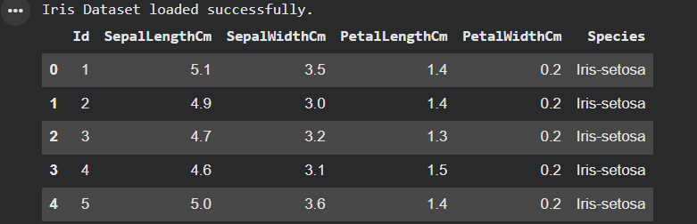
2. Identify and Document Dataset Characteristics
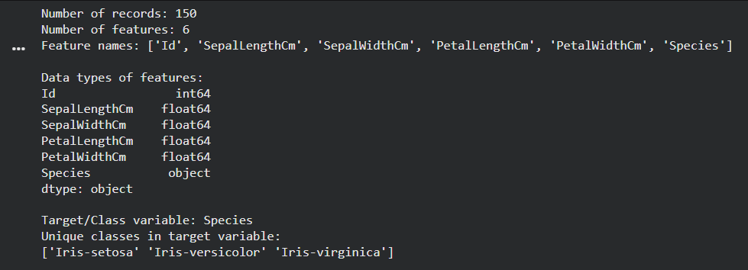
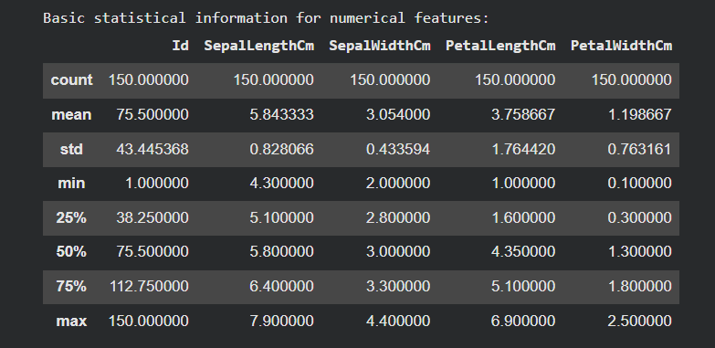
3. Numerical Analysis using NumPy
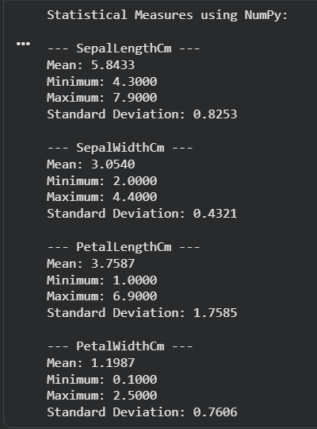
4. Data Manipulation using Pandas
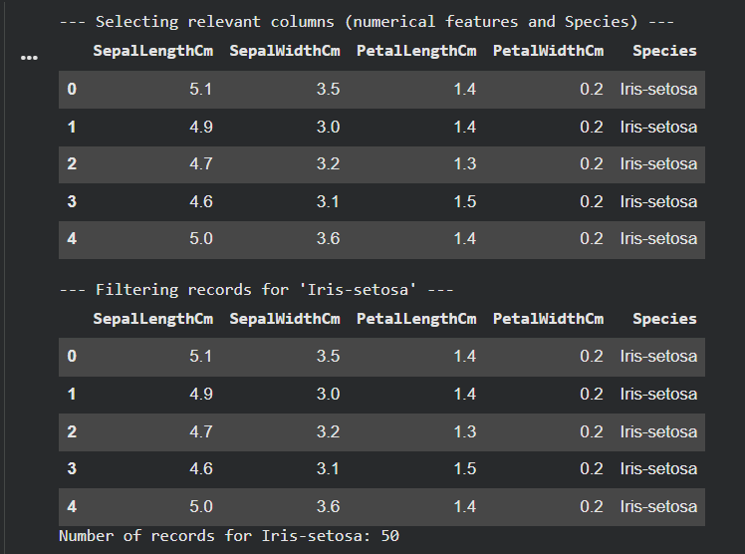
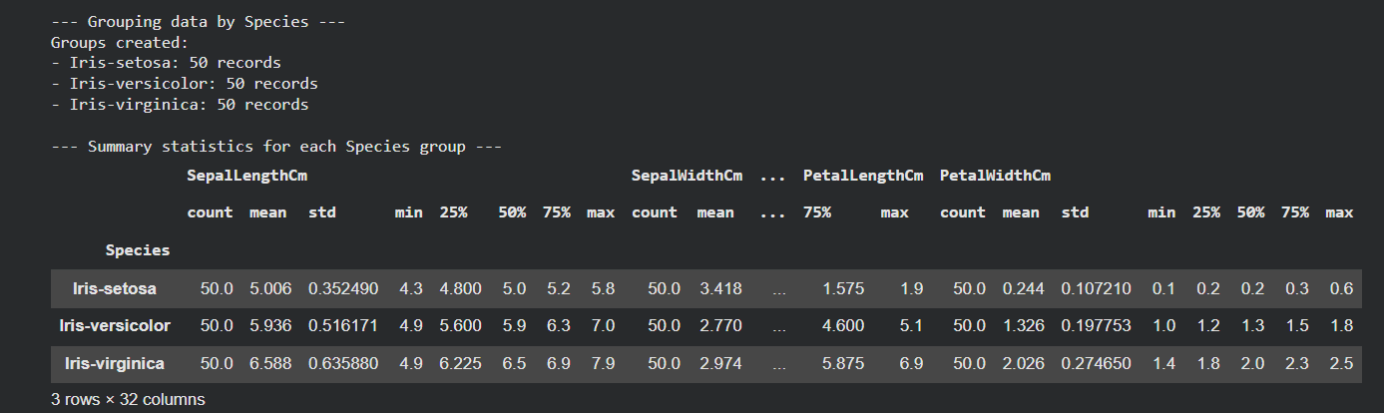
5. Visualizations using Matplotlib
Generating visualizations...
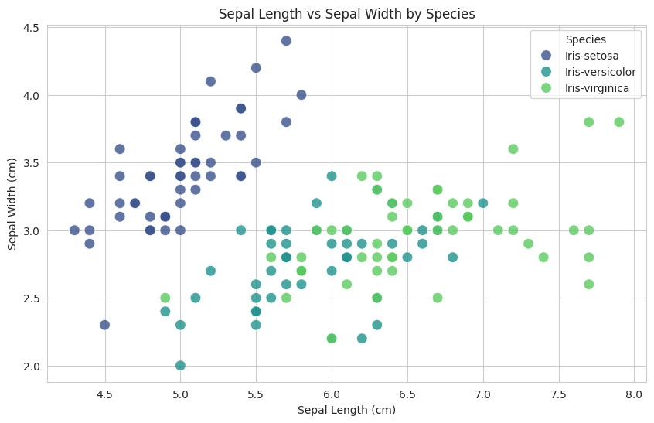
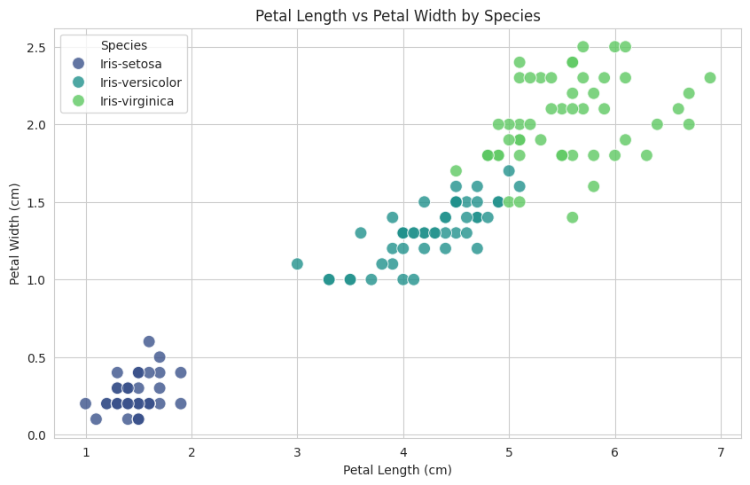
Generating Pair Plot (this may take a moment)...
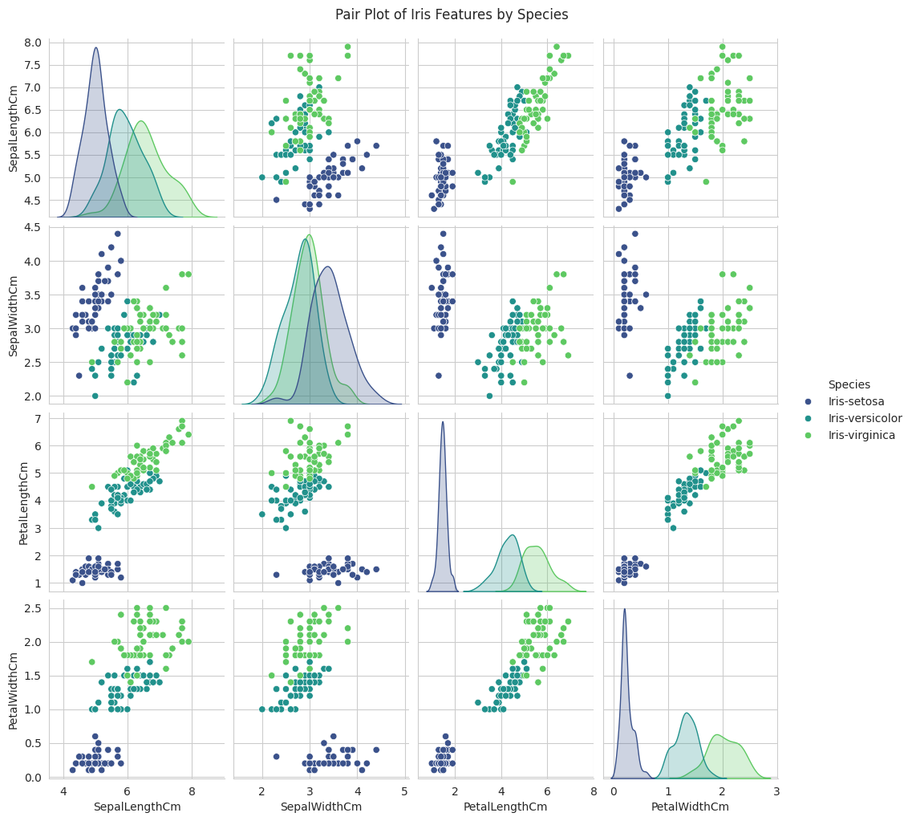
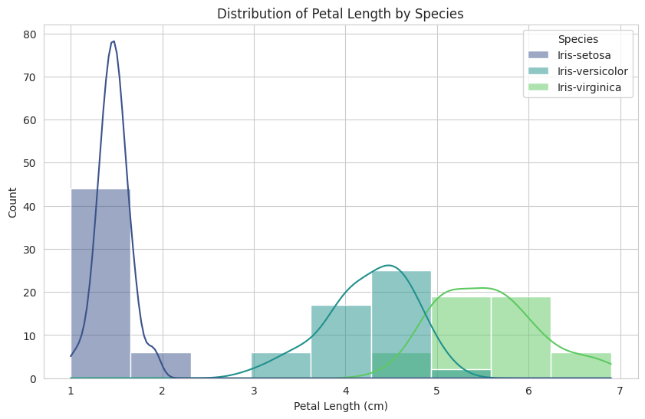
6. Model Training and Evaluation (Confusion Matrix)
Data split into training and testing sets.
Training set shape: (105, 4)
Testing set shape: (45, 4)
Logistic Regression model trained.
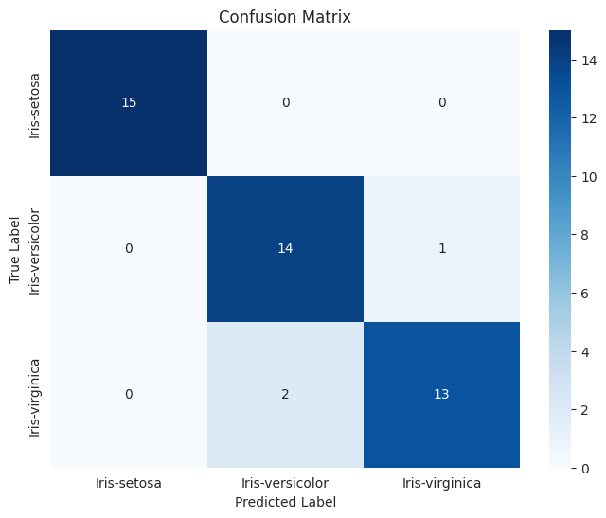
Classification Report:
precision recall f1-score support

Iris-setosa 1.00 1.00 1.00 15
Iris-versicolor 0.88 0.93 0.90 15
Iris-virginica 0.93 0.87 0.90 15

accuracy 0.93 45
macro avg 0.93 0.93 0.93 45
weighted avg 0.93 0.93 0.93 45

8. Compare with Random Forest Classifier
Training Random Forest Classifier...
Random Forest Classifier trained successfully.

Random Forest Accuracy: 0.8889

Random Forest Classification Report:
precision recall f1-score support

Iris-setosa 1.00 1.00 1.00 15
Iris-versicolor 0.78 0.93 0.85 15
Iris-virginica 0.92 0.73 0.81 15

accuracy 0.89 45
macro avg 0.90 0.89 0.89 45
weighted avg 0.90 0.89 0.89 45

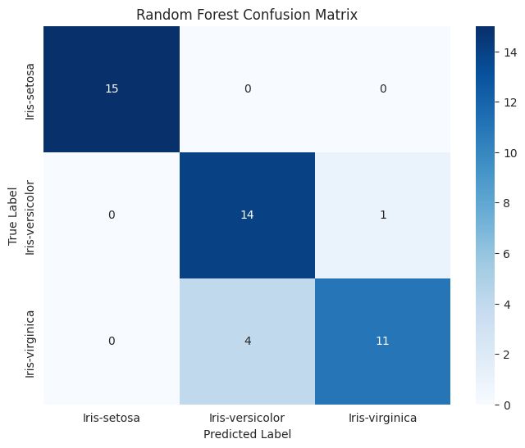

10. Hyperparameter Tuning for Random Forest Classifier
Performing hyperparameter tuning for Random Forest Classifier...
Fitting 5 folds for each of 108 candidates, totalling 540 fits
Hyperparameter tuning complete.

Best parameters found: {'max_depth': None, 'min_samples_leaf': 1, 'min_samples_split': 5, 'n_estimators': 150}
Best cross-validation accuracy: 0.9619

Best Random Forest Test Accuracy: 0.9111

Best Random Forest Classification Report:
precision recall f1-score support

Iris-setosa 1.00 1.00 1.00 15
Iris-versicolor 0.82 0.93 0.88 15
Iris-virginica 0.92 0.80 0.86 15

accuracy 0.91 45
macro avg 0.92 0.91 0.91 45
weighted avg 0.92 0.91 0.91 45

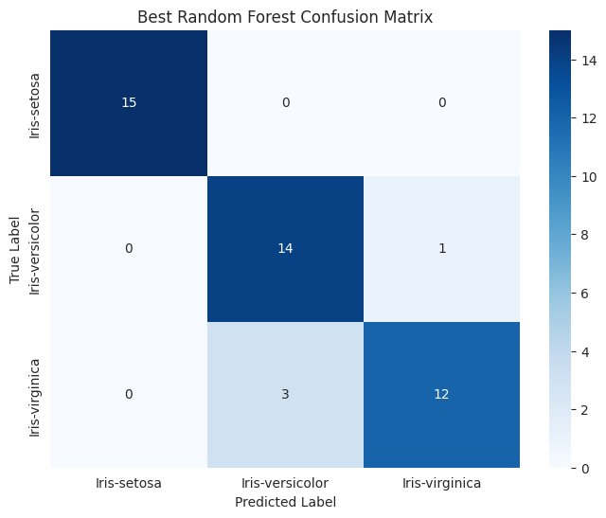
9. Additional Visualizations: Bar, Line, and Bubble Graphs
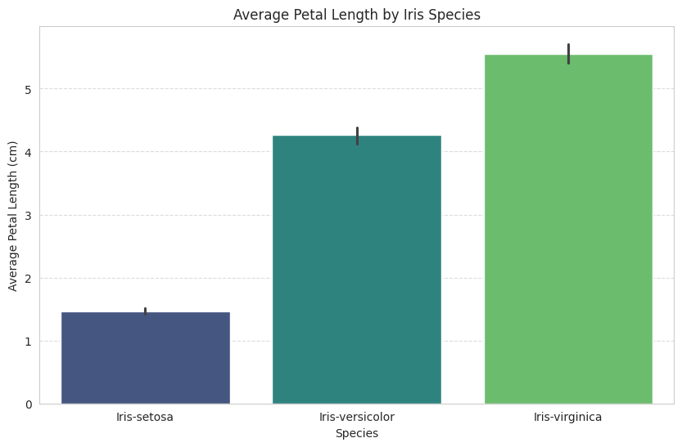
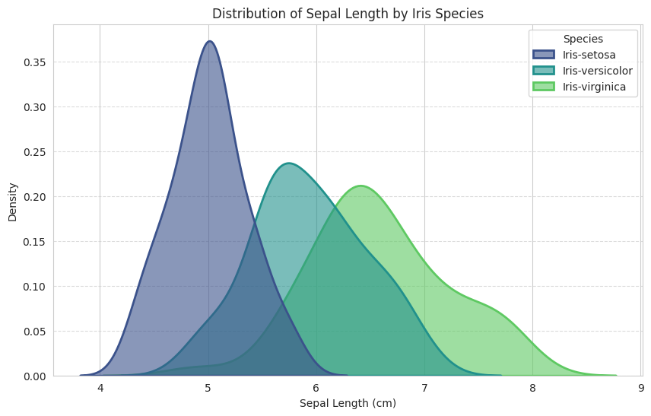
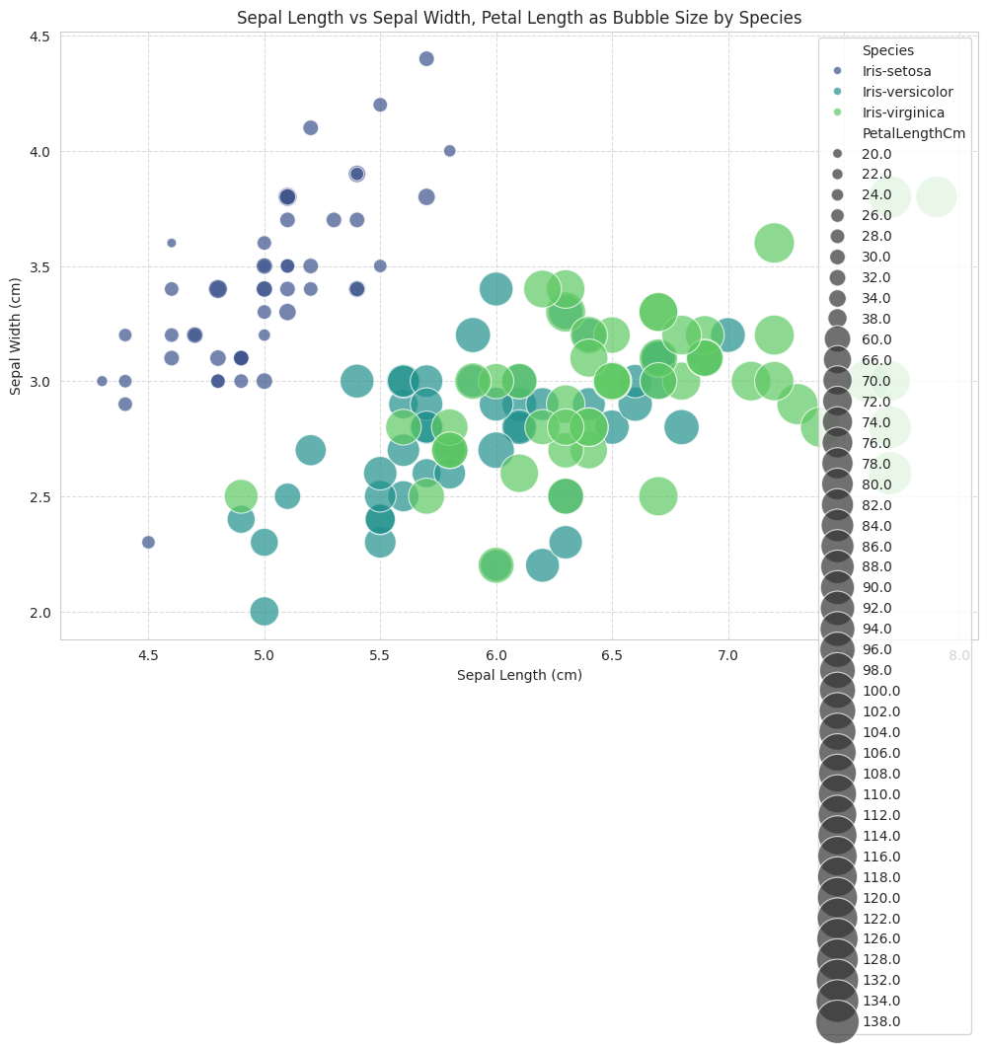
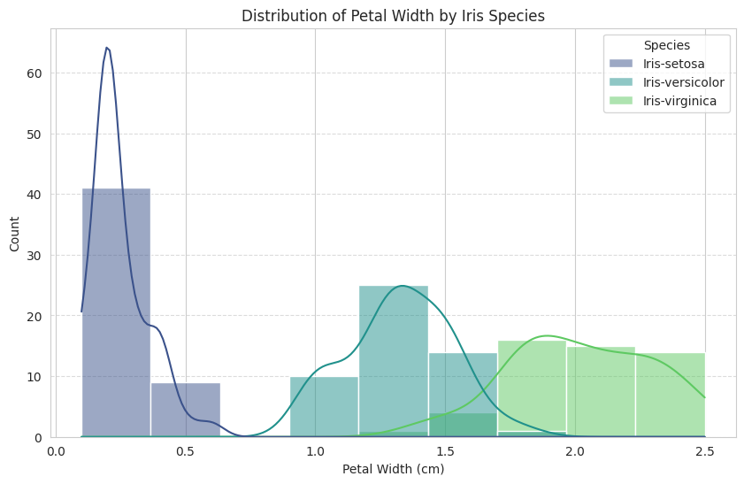
7. Feature Importance Plot
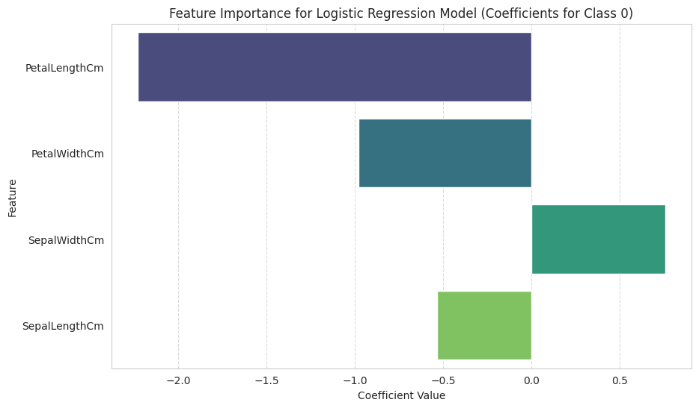
Features sorted by their importance (absolute coefficient value) for class 0:
 | Feature | Importance
0 | PetalLengthCm | -2.227863
1 | PetalWidthCm | -0.979102
2 | SepalWidthCm | 0.756772
3 | SepalLengthCm | -0.533397

Question 2
Execute a basic Machine Learning data analysis workflow using the same Iris Dataset
analyzed in Question 1 to explore the concepts of Supervised and Unsupervised Learning.
Use the features, statistical results, and visualizations obtained in Question 1 to identify the input
features and target variable and determine how the dataset can be applied to a Supervised
Learning problem. Further, analyze the same feature data without using the target labels to
explore possible natural groups or patterns representing an Unsupervised Learning problem.
Analyze the relationship between the findings from Question 1 and the selection of an
appropriate learning approach. Evaluate the differences between Supervised and Unsupervised
Learning and explain their suitability for different real-world AI applications.
This activity builds on the data analysis performed in Question 1 and develops Machine
Learning knowledge (WK4, WK6) through the application of modern Python tools to the same
dataset. It develops EC3 (Problem Analysis) by investigating the dataset and EC4 (Design and
Development of Solutions) by selecting an appropriate Machine Learning approach. The
activity supports PLO-02 (Problem Analysis) and PLO-03 (Design/Development of
Solutions) and contributes to SDG 9 (Industry, Innovation and Infrastructure) through the
application of AI and data-driven technologies.
Task Requirements
1. Use the Iris Dataset and the analysis performed in Question 1 as the basis for this task.
2. Identify:
o Input features
o Target variable
o Type of Machine Learning problem
o Expected output
3. Execute the identification of a Supervised Learning problem using the Iris flower class as the target variable and explain how the features analyzed in Question 1 can be used for classification.
4. Execute an Unsupervised Learning data exploration by using the same numerical features without using the target/class labels to investigate possible natural groups or patterns.
5. Use the visualizations/results from Question 1 to compare the feature patterns observed with the possible groups identified through the Unsupervised Learning approach.
6. Analyze at least two differences between Supervised and Unsupervised Learning in terms of:
o Target variable
o Learning objective
o Expected output
o Use of labelled/unlabelled data
7. Give at least two real-world applications of each learning approach and relate them to the type of problem they solve.
8. Evaluate why the choice between Supervised and Unsupervised Learning depends on the
availability of labelled data and the objective of the AI application.

[CLO- 02, PLO-03, P4 (Execute) (WK5, EC4, and SDG 11) Rubric (Syntax, Logic, Completeness, (Outcome) Points (12)]

SOLUTION:

1. Load the Iris Dataset
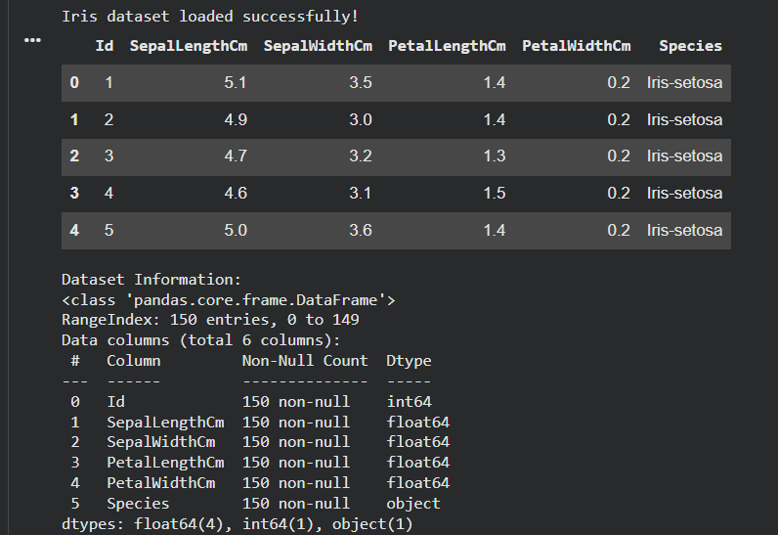
2. Identify Input Features, Target Variable, and Problem Type
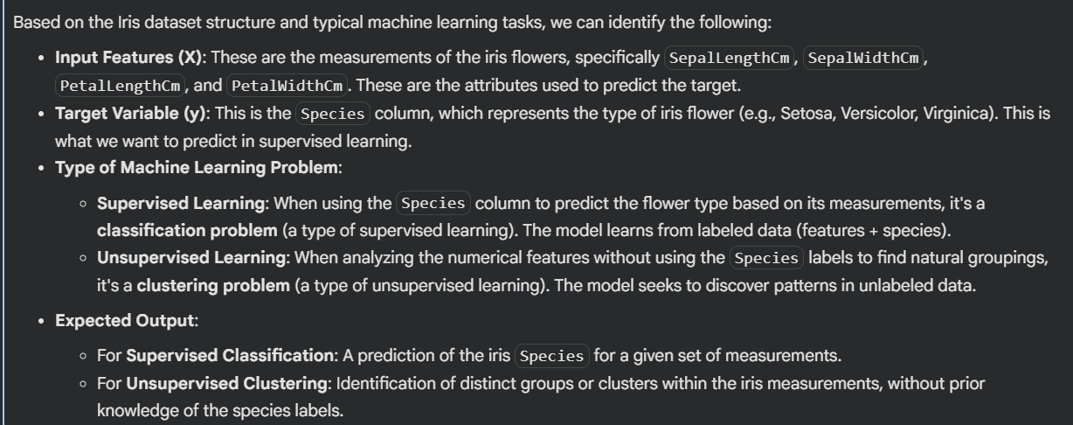
3. Execute Supervised Learning: Classification Problem (Iris Species Prediction)
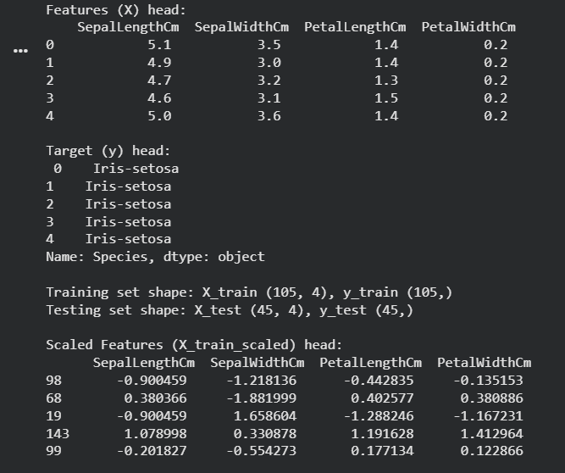
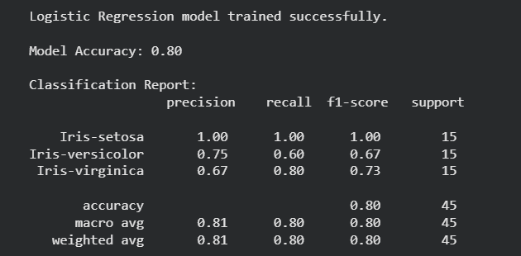
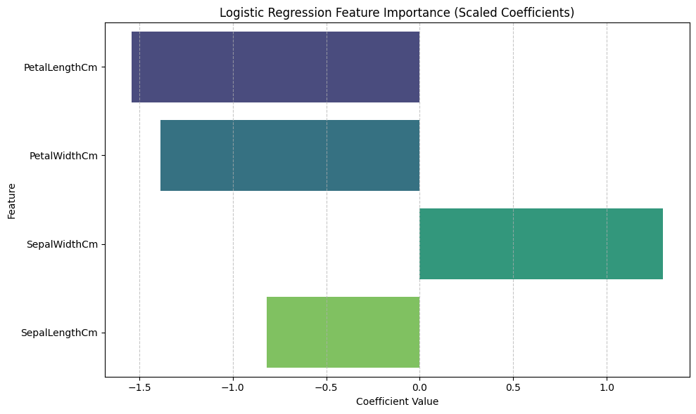
Additional Visualization: Pair Plot of Features by Species
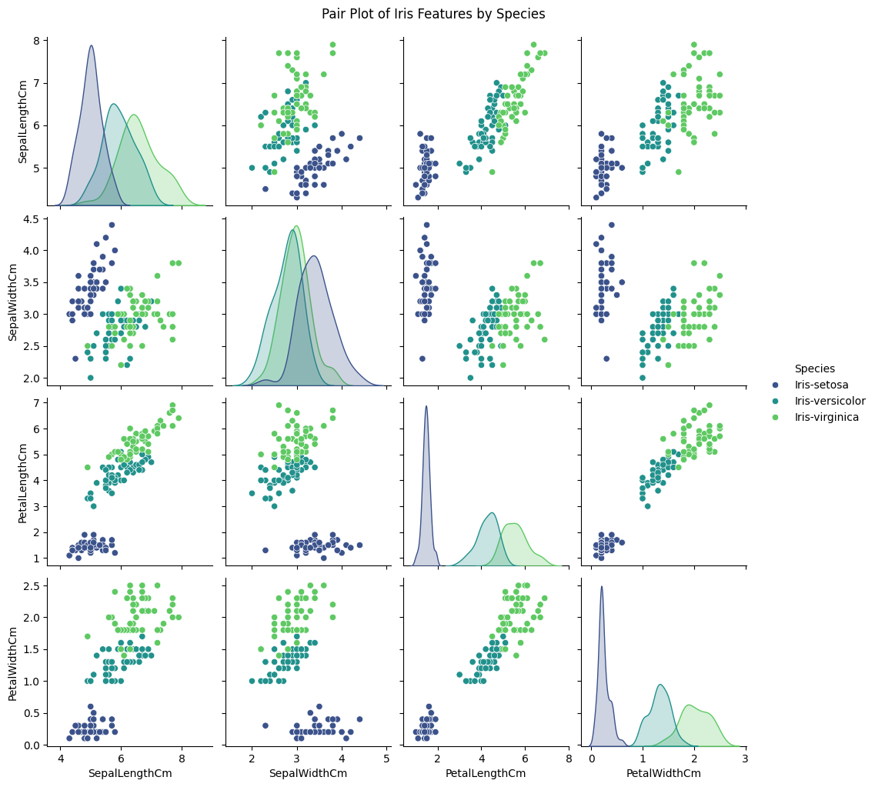
4. Execute Unsupervised Learning: Clustering Problem
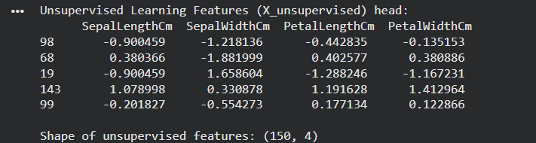
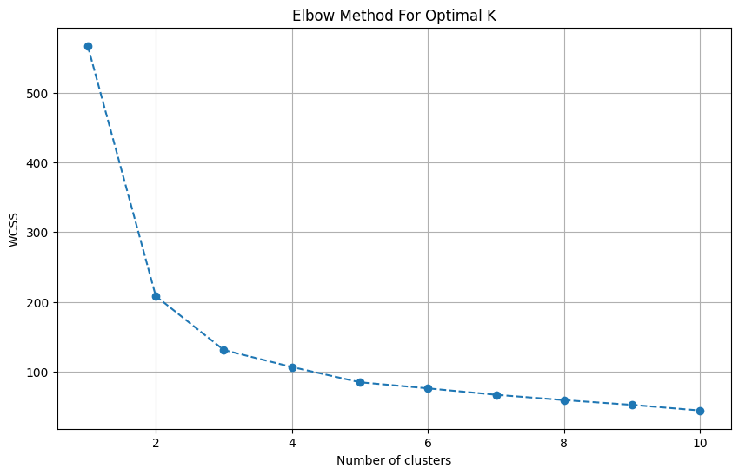
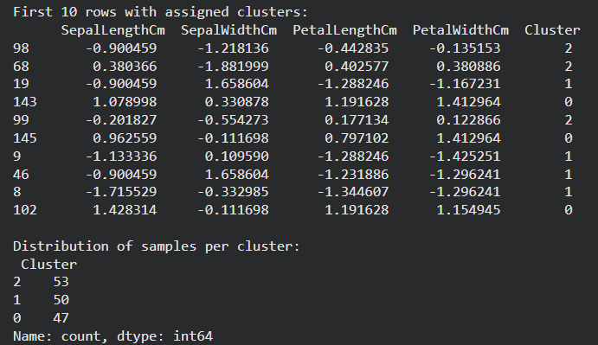
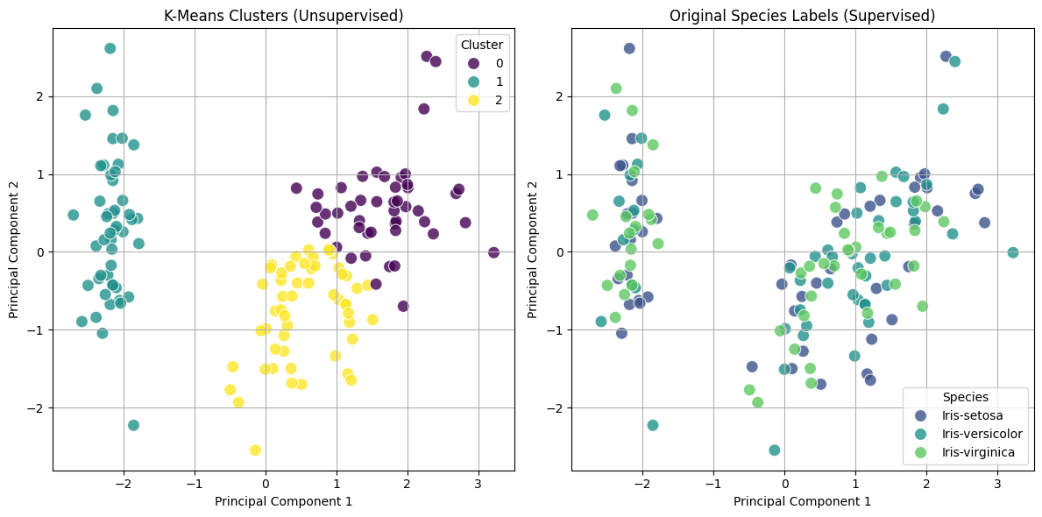
6. Differences Between Supervised and Unsupervised Learning
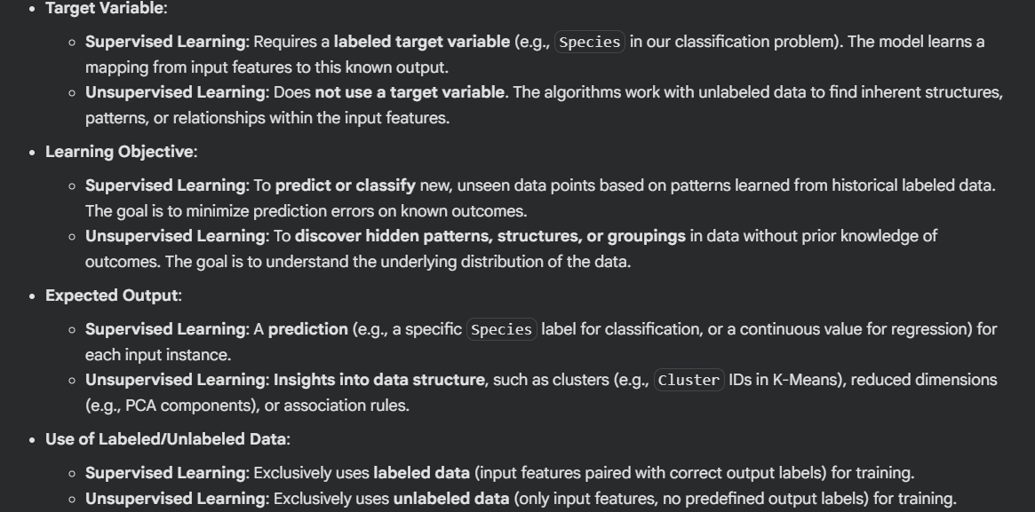
7. Real-World Applications of Each Learning Approach
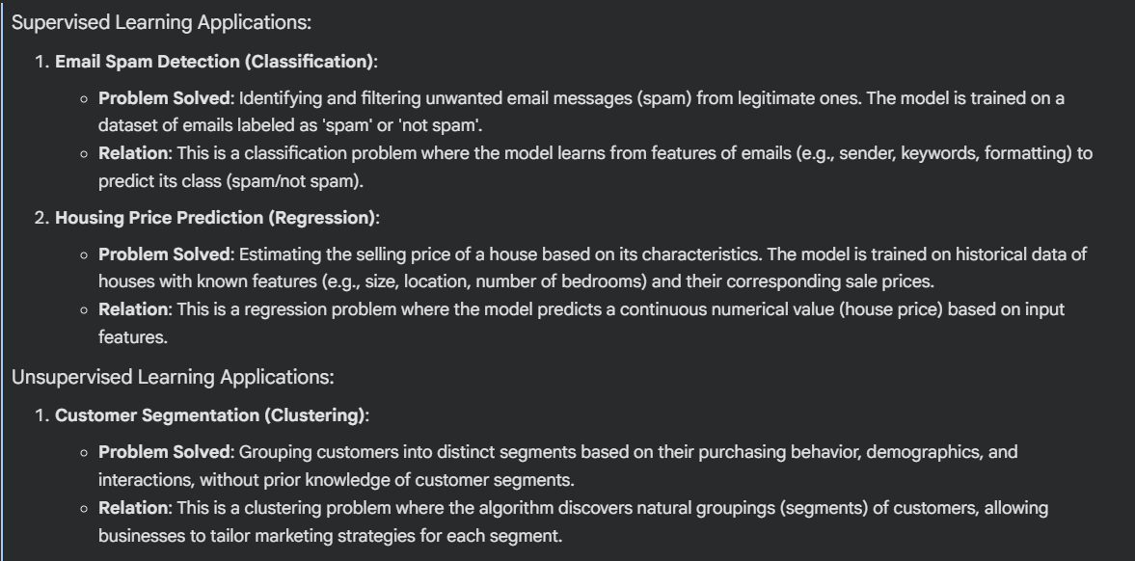
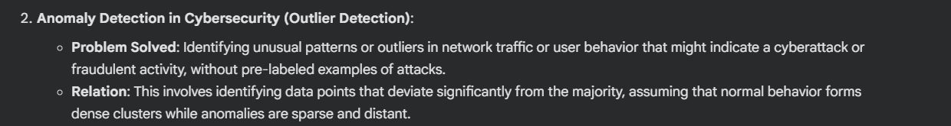
8. Evaluation of Choice Between Supervised and Unsupervised Learning
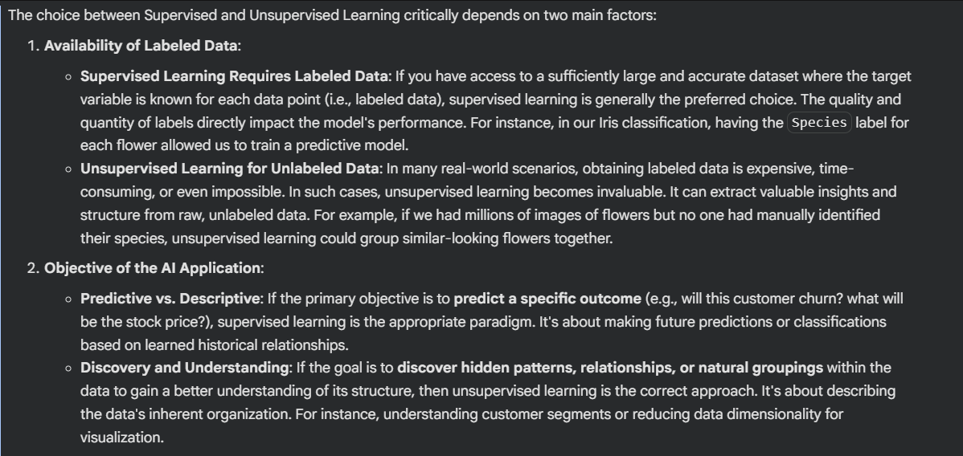

Comparison of K-Means Clusters vs. Original Species Labels (Cross-Tabulation)
